## Front End Engineering II

Project Report

Semester-IV (Batch-2022)

**Forkify Recipes**

**Supervised By: Submitted By:**

Dr. Baljeet Kaur Jinny Kapur (2210990462)

Jiya Gaba (2210990464)

Kashika (2210990493)

Jashanjit Kaur (2210990440)

**Department of Computer Science and Engineering**

## Chitkara University Institute of Engineering & Technology,

## Chitkara University, Punjab

**INDEX:**

|  |  |  |
| --- | --- | --- |
| **S. No.** | **Title** | **Page Number** |
| # | Abstract | 3 |
| 1. | Introduction | 4 – 5 |
| 2. | Problem Statement | 6 – 7 |
| 3. | Proposed Design | 8 – 11 |
| 4. | Result | 12 – 13 |
| 5. | Project Screenshots | 14 – 16 |
| 6. | Reference/Links | 17 |

**Abstract:**

This project report presents "Forkify Recipes," an advanced web application developed using React, aimed at offering users a vast and diverse collection of recipes from various cuisines worldwide.

The "Forkify Recipes" application is built with a focus on modern web development practices and technologies. React, a popular JavaScript library for building user interfaces, serves as the foundation of the project. React component-based architecture facilitates the creation of a dynamic and responsive user interface, ensuring a seamless user experience. The application leverages React hooks for state management, making the application more efficient and reducing complexity in code maintenance.

To enhance the visual appeal and usability of the application, Tailwind CSS has been integrated. Tailwind CSS is a utility-first CSS framework that provides a highly customizable design system, enabling the development of a visually cohesive and attractive interface. This ensures that the application is not only functional but also aesthetically pleasing, which is crucial for user engagement and satisfaction.

JavaScript plays a vital role in the functionality of the "Forkify Recipes" application. It is used extensively for handling user interactions, performing API calls, and managing application state. The integration of JavaScript allows for a more interactive and dynamic experience, making the application responsive to user inputs and capable of delivering real-time feedback.

One of the standout features of the "Forkify Recipes" application is its ability to fetch recipes from external APIs. The application utilizes API fetching to search for recipes based on user input, providing a vast array of culinary options. This feature is implemented using modern asynchronous JavaScript techniques, such as async/await, to handle data fetching and ensure smooth and efficient data retrieval. By leveraging external APIs, the application can offer an extensive database of recipes, ensuring users have access to a wide variety of culinary delights.

1. **Introduction:**

In the contemporary landscape of digital platforms and culinary exploration, the intersection of technology and gastronomy has become increasingly prominent. In response to this trend, our project, titled "Forkify," endeavors to merge the realms of web development and culinary arts to offer users an immersive and enriching experience in recipe discovery and exploration.

**1.1 Background**

The genesis of "Forkify" stems from the realization of the burgeoning interest in culinary experimentation among individuals of diverse backgrounds. With the advent of digitalization, the accessibility of culinary resources has witnessed a paradigm shift. Traditional cookbooks have made way for dynamic, interactive recipe applications, empowering users to explore a myriad of culinary possibilities with just a few clicks.

This shift has been further propelled by the rise of social media influencers, cooking bloggers, and online communities dedicated to food appreciation. The virtual landscape is now inundated with a plethora of recipes, cooking tutorials, and culinary inspirations, catering to the diverse palates and dietary preferences of a global audience.

**1.2 Objective**

The primary objective of "Forkify" is to provide a user-friendly platform that amalgamates cutting-edge web technologies with a vast repository of culinary knowledge. By leveraging React for front-end development, Tailwind CSS for efficient styling, and API fetching for real-time data acquisition, our aim is to create an intuitive interface where users can seamlessly browse through thousands of recipes, each accompanied by detailed ingredient lists, nutritional information, and health labels.

Furthermore, "Forkify" seeks to bridge the gap between culinary creativity and nutritional awareness. In addition to facilitating recipe discovery, our platform prioritizes user health by offering comprehensive nutritional insights. By incorporating features such as calorie counts, preparation times, serving sizes, and health labels, we aim to empower users to make informed dietary choices that align with their individual wellness goals.

**­1.3 Significance**

The significance of "Forkify" lies in its ability to cater to the evolving needs and preferences of modern-day consumers. With the relentless pace of life, individuals are constantly seeking convenient yet wholesome meal solutions. By offering a comprehensive platform that not only facilitates recipe discovery but also provides crucial nutritional insights, "Forkify" aims to empower users to make informed dietary choices without compromising on flavor or creativity.

Moreover, "Forkify" serves as a testament to the transformative power of technology in revolutionizing traditional domains such as cooking and nutrition. By harnessing the capabilities of web development and API integration, we have created a digital ecosystem where culinary enthusiasts can converge, explore, and elevate their gastronomic experiences.

In essence, "Forkify" represents a harmonious blend of innovation and tradition, where the timeless art of cooking meets the dynamic world of digitalization. Through our platform, we aspire to inspire culinary creativity, promote healthy living, and foster a sense of community among food enthusiasts worldwide.

**2. Problem Statement**

The realm of culinary exploration in the digital age presents both opportunities and challenges for aspiring chefs, home cooks, and food enthusiasts alike. While the internet offers a vast repository of recipes and culinary inspirations, navigating through this abundance of information can often prove daunting and overwhelming. Additionally, the lack of comprehensive nutritional insights accompanying many online recipes leaves users uninformed about the health implications of their culinary choices.

Considering these challenges, the problem statement for our project, "Forkify," can be articulated as follows:

1. **Lack of Centralized Platform for Recipe Discovery**

Existing online platforms for recipe discovery often lack a centralized repository of recipes that cater to diverse culinary preferences and dietary requirements. Users are frequently required to visit multiple websites or sift through countless search results to find recipes that align with their specific needs and preferences.

1. **Insufficient Nutritional Information**

Many online recipes lack comprehensive nutritional information, including calorie counts, macronutrient breakdowns, and health labels. This dearth of nutritional insights hampers users' ability to make informed dietary choices, leading to potential health implications and nutritional imbalances.

1. **User Experience and Interface Complexity**

Navigating through existing recipe websites and applications can be cumbersome and inefficient, with cluttered interfaces and confusing navigation structures hindering user experience. The lack of intuitive design elements and user-friendly features detracts from the overall enjoyment and utility of these platforms.

1. **Limited Integration of Modern Web Technologies**

While the potential of modern web technologies such as React and API integration in enhancing the user experience of recipe applications is well-recognized, many existing platforms fail to fully leverage these capabilities. The underutilization of advanced web development tools and techniques impedes innovation and limits the functionality of recipe discovery platforms.

Considering these identified challenges, the development of "Forkify" aims to address these pain points by providing users with a centralized, intuitive, and comprehensive platform for recipe discovery, accompanied by detailed nutritional insights and leveraging modern web technologies to enhance the overall user experience.

**3. Proposed Design**

The proposed design for "Forkify" is carefully crafted to provide users with a seamless and enriching experience in recipe discovery and exploration. This section delves deeper into the technologies used in the development process and elaborates on the method of use for the end user, offering comprehensive insights into the platform's functionality and user experience.

**3.1 Technologies Used**

The various technologies used for making the project are mentioned below: -

1. **React**­

React is an open-source JavaScript Library used for building User interface. It simplifies the creation of SPA (Single Page Assignment) by using reusable components.

React.js stands as the foundational framework for the front-end development of "Forkify." Renowned for its component-based architecture and virtual DOM rendering, react enables the creation of dynamic and responsive user interfaces that adapt seamlessly to varying screen sizes and device types. By breaking down the user interface into reusable components, react promotes code reusability, maintainability, and scalability, facilitating the development of a robust and efficient recipe discovery platform.

Features of React used in project: -

1. **Virtual DOM:**

React utilizes a virtual representation of the DOM, allowing efficient updates by minimizing direct manipulation of the actual DOM, resulting in improved performance.

1. **Component-Based Architecture:**

React structures user interfaces as modular, reusable components, promoting a maintainable and scalable approach to building applications.

Advantages of using React: –

* Simple to build Single Page Application (by using Components)
* React is cross platform and open source (Free to use)
* Lightweight and very fast (Virtual DOM)
* Large Community and Ecosystem
* Testing is easy

Apps.js file in React: –

* App.js file contains the root components of react application.
* App component is like a container for other components.
* App.js define the structure, layout, and routing in the application.

1. **Reusability & Composition**

React enables the creation of reusable components that can be composed together, fostering a modular and efficient development process.

1. **JSX (JavaScript XML):**

JSX is a syntax extension for JavaScript used in React, allowing developers to write HTML-like code within JavaScript, enhancing readability and maintainability.

Props in JSX – Props(properties) are a way to pass data from a parent component to a child component.

React uses Babel library to convert JSX code to actual JavaScript code as browser understand JavaScript, not JSX.

Fragment- JSX do not consider separate elements so, a single div <> </> called fragment is used.

1. **Declarative Syntax:**

React have a declarative programming style (JSX), where developers focus on "what" the Ul should look like and React handles the "how" behind the scenes. This simplifies the code.

1. **Community & Ecosystem:**

React benefits from a vibrant and extensive community, contributing to a rich ecosystem of libraries, tools, and resources, fostering collaborative development and innovation.

1. **React Hooks:**

Hooks are functions that enable functional components to manage state and lifecycle features, providing a more concise and expressive way to handle component logic.

1. **Tailwind CSS**

Tailwind CSS emerges as the styling framework of choice for "Forkify," offering a pragmatic and utility-first approach to CSS development. By harnessing Tailwind's extensive library of utility classes and pre-designed components, we expedite the styling process, eliminating the need for custom CSS stylesheets and reducing development overhead. Tailwind's intuitive class-based syntax empowers developers to rapidly prototype and iterate on the visual design of "Forkify," ensuring consistency and coherence in the presentation of user interface elements across the platform.

1. **API Fetching**

API fetching serves as the backbone of "Forkify," enabling the dynamic retrieval of recipe data from external sources to populate the platform's extensive recipe database. Through seamless integration with API that is Edamam API which we have used, "Forkify" ensures real-time access to a diverse array of culinary inspirations, encompassing cuisines from around the globe and catering to various dietary preferences and restrictions. By leveraging the power of API fetching, we empower users to explore and discover new recipes with ease, enriching their culinary repertoire and fostering a culture of experimentation and creativity.

**3.2 Method of Use**

1. **Search and Browse**

At the heart of "Forkify" lies a robust search and browsing functionality, designed to facilitate seamless recipe discovery and exploration. Users can initiate their culinary journey by entering specific keywords, ingredients, or dietary preferences into the search bar, thereby accessing a curated selection of recipes tailored to their individual preferences. The platform offers advanced filtering options, allowing users to refine their search results based on criteria such as cuisine type, meal category, cooking time, and allergen restrictions. Whether craving a quick weeknight dinner or embarking on a gourmet culinary adventure, users can rely on "Forkify" to deliver personalized recipe recommendations that cater to their unique tastes and preferences.

1. **Recipe Details**

Upon selecting a recipe of interest, users are presented with comprehensive details about the chosen dish, encompassing ingredient lists, step-by-step preparation instructions, estimated preparation time, serving sizes, and health labels. Nutritional information, including calorie counts, macronutrient breakdowns, and dietary considerations, is prominently displayed to empower users to make informed dietary choices and align their meal plans with their health and wellness goals. Additionally, "Forkify" offers supplementary information such as cooking tips, ingredient substitutions, and serving suggestions, enriching the user experience and enhancing the utility of the platform as a culinary resource.

1. **Interactive Interface**

"Forkify" boasts an intuitive and interactive interface designed to engage users and enhance their overall browsing experience. The platform features visually appealing recipe cards, enriched with high-quality imagery and enticing descriptions, enticing users to explore and discover new culinary delights. Users can interact with recipe cards by liking, saving, or sharing their favorite recipes, fostering a sense of community and collaboration among food enthusiasts. Furthermore, "Forkify" offers customizable viewing modes, allowing users to toggle between grid or list layouts, adjust font sizes and color schemes, and personalize their browsing experience to suit their preferences. By prioritizing accessibility, usability, and interactivity, "Forkify" strives to deliver a seamless and enjoyable user experience that inspires culinary creativity and fosters a lifelong passion for cooking and gastronomy.

**4. Results**

The development and implementation of "Forkify" culminated in a robust and user-friendly platform for recipe discovery and exploration. This section highlights the key outcomes and achievements of the project, including user feedback, performance metrics, and future enhancements.

**4.1 User Feedback**

Initial feedback from users who interacted with "Forkify" has been overwhelmingly positive, with many praising the platform's intuitive interface, comprehensive recipe database, and nutritional insights. Users appreciated the ease of navigation, advanced search capabilities, and interactive features such as recipe saving and sharing. Additionally, users expressed satisfaction with the platform's responsiveness across different devices and screen sizes, highlighting the seamless user experience delivered by "Forkify."

**4.2 Performance Metrics**

Performance metrics gathered during the testing phase indicate the efficiency and reliability of "Forkify" in delivering recipe content to users. Key performance indicators such as page load times, API response times, and server uptime were consistently within acceptable thresholds, ensuring a smooth and uninterrupted browsing experience for users. The platform's scalability and resilience were tested under varying load conditions, demonstrating its ability to handle concurrent user requests and maintain optimal performance levels.

**4.3 Future Enhancements**

Building upon the success of the initial release, future enhancements for "Forkify" are envisioned to further enrich the platform's functionality and user experience. Proposed enhancements include:

* **Enhanced Personalization**: Introducing personalized recipe recommendations based on user preferences, browsing history, and dietary profiles to tailor the user experience and foster deeper engagement.
* **Integration with Smart Kitchen Devices**: Partnering with smart kitchen device manufacturers to enable seamless integration with "Forkify," allowing users to synchronize recipe instructions with smart appliances for hands-free cooking experiences.
* **Community Features**: Implementing community-driven features such as user-generated content, recipe sharing forums, and collaborative cooking challenges to foster a sense of community and camaraderie among "Forkify" users.
* **Accessibility Improvements**: Enhancing accessibility features to ensure inclusivity and usability for users with diverse needs and abilities, including support for screen readers, keyboard navigation, and color contrast adjustments.
* **Internationalization and Localization**: Expanding language support and cultural adaptation to cater to a global audience, enabling users from different regions to access "Forkify" in their preferred language and discover recipes from diverse culinary traditions.

**4.4 Conclusion**

In conclusion, the development of "Forkify" represents a significant milestone in the convergence of technology and culinary arts, offering users a sophisticated yet accessible platform for recipe discovery and exploration. The positive feedback received from users, coupled with the platform's robust performance metrics, underscores the success of "Forkify" in meeting the needs and expectations of its target audience. Moving forward, the project team remains committed to continuous improvement and innovation, ensuring that "Forkify" remains at the forefront of digital culinary experiences and continues to inspire culinary creativity and exploration among users worldwide.

**5. Project Screenshots:**

1. Home Page

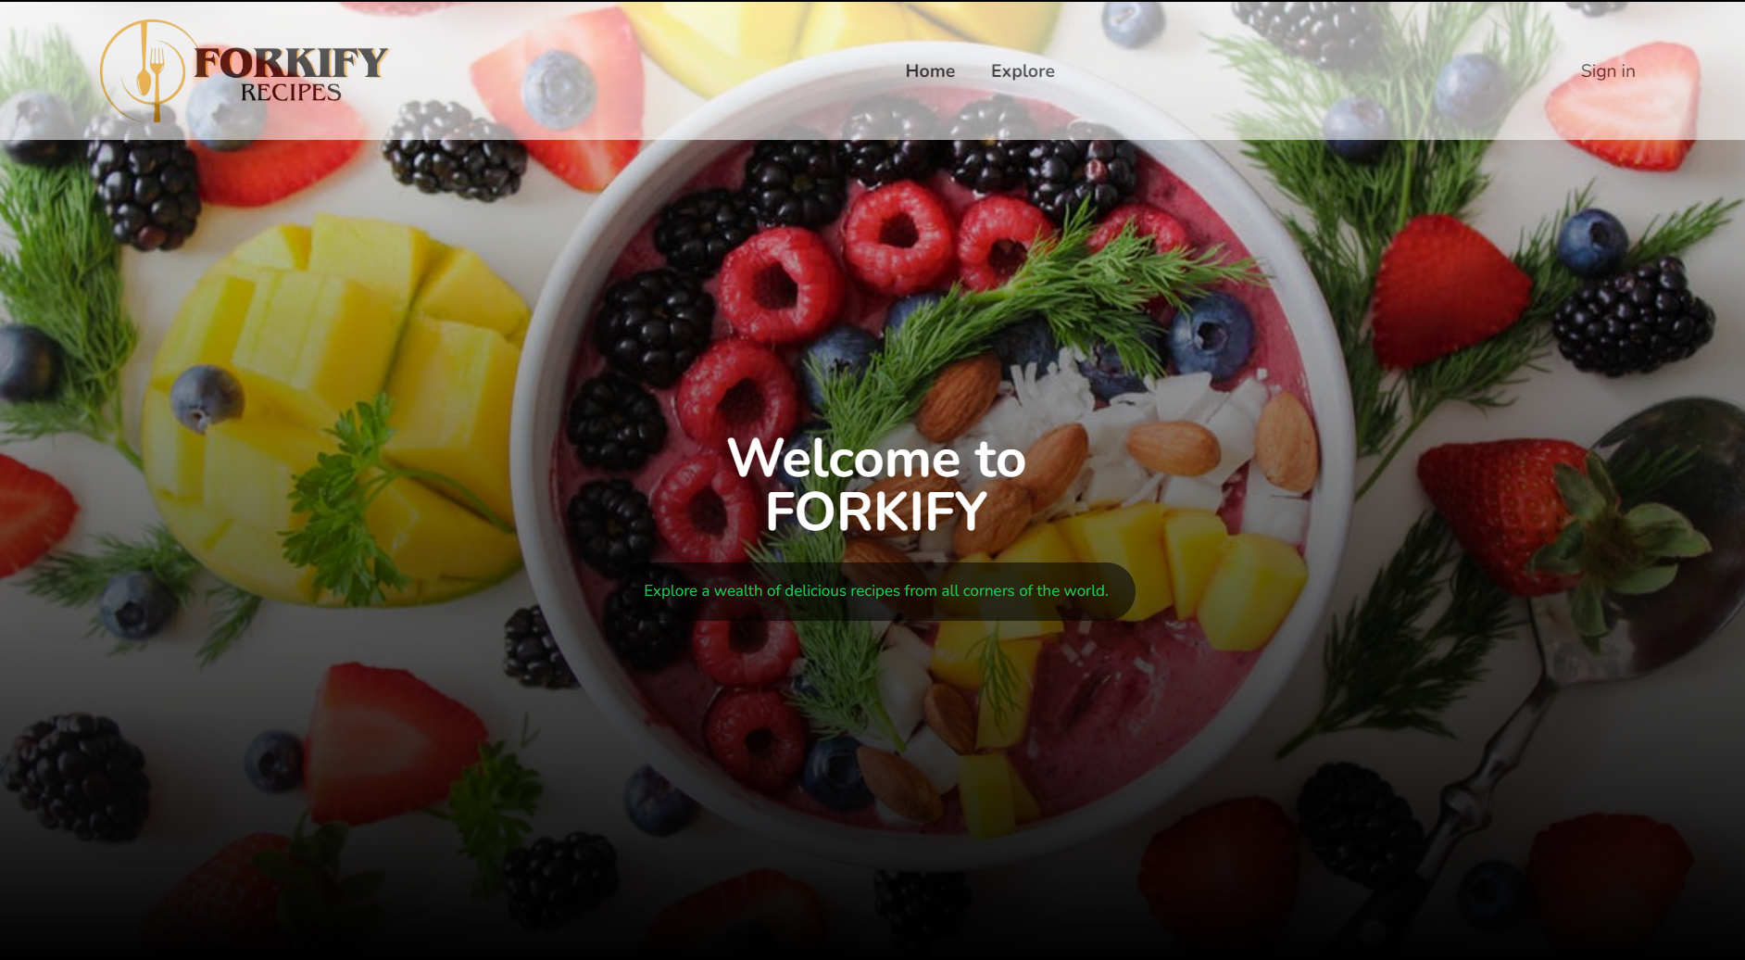

1. Search for Recipes

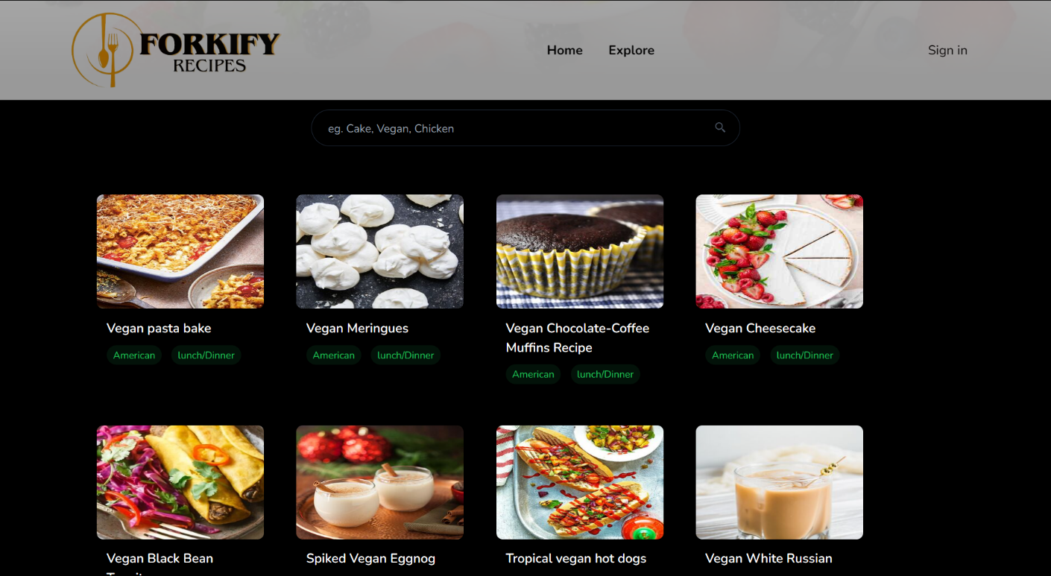

1. Footer

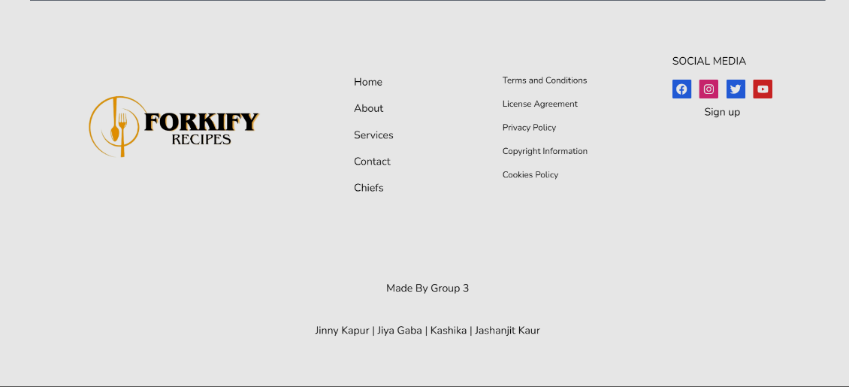

1. Selected Recipe

1. Ingredients and Health Labels of selected Recipe-

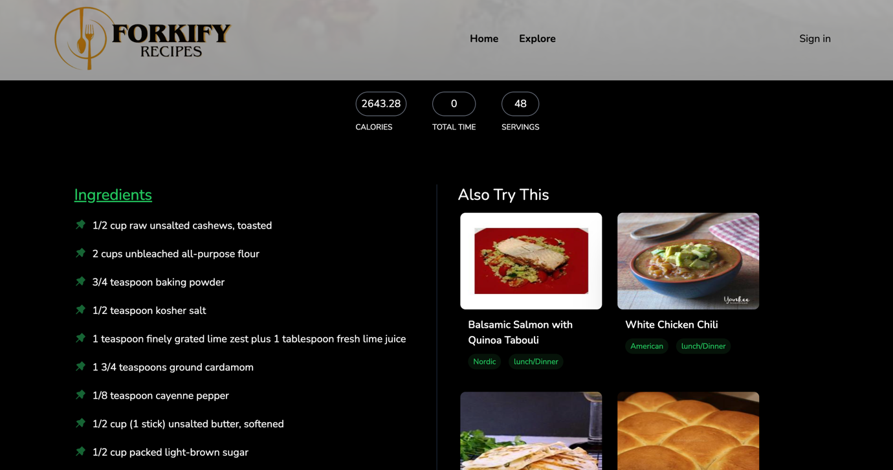

1. **Reference/Links:**

* **Udemy:** <https://www.udemy.com/personal/home>
* **GitHub:** <https://github.com/>
* **YouTube:** <https://www.youtube.com/>